FORM NO. 5 | EXTRA FURNITURE & ELECTRIC LOAD

Submission Deadline: 20-02-2023

EXTRA FURNITURE

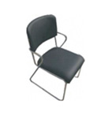 | 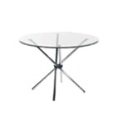 | 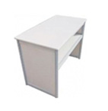 | 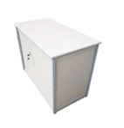
Black Leather Chair | Glass Round Table | Information Counter | Lockable Counter
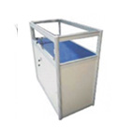 | 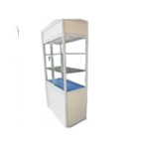 | 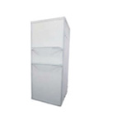 | 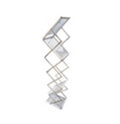
Small Showcase | Tall Showcase | Glass Shelf | Folding Brochure Rack
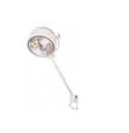 | 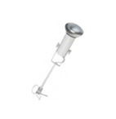 | 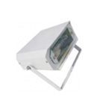 | 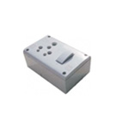
Long Arm Light | Spot Light | Metal Light / LED | Power Point

FORM NO. 5 | EXTRA FURNITURE & ELECTRIC LOAD

Submission Deadline: 20-02-2023
Company Name

CODE | ITEMS | SIZES | INR | USD | QTY | TOTAL
ME-C 01 | Black Leather Chair | 460x430x832mm H | 1500 | 21
ME-T 01 | Glass Round Table | 800Dx 760mm H | 2500 | 36
ME-SYS 01 | Information Counter | 1030x535x760mm H | 2500 | 36
ME-SYS 02 | Lockable Counter | 1030x535x760mm H | 3500 | 50
ME-SYS 05 | Small Showcase | 1030x535x1030mm H | 5000 | 71
ME-SYS 07 | Tall Showcase | 1030x535x2000mm H | 8000 | 115
ME-SYS 12 | Glass Shelf | 300x1000mm H | 1000 | 15
ME-A 01 | Folding Brochure Rack | 380x270x1380mm H | 2000 | 30
ME-E 01 | Long Arm Light | 150 Watt | 1100 | 16
ME-E 02 | Spot Light | 100 Watt | 1250 | 18
ME-E 09 | Metal Light / LED | 70 Watt | 3500 | 50
ME-E 10 | Power Point | 15 Amp | 700 | 10
EE-S-2 | Extra Electricity Single Phase | 220V/ 50Hz Supply (Per KW) | 4000 | 60
EE-T-4 | Extra Electricity Three Phase | 415V/ 50Hz Supply (Per KW) | 4000 | 60
 |  | TOTAL
Please return this form to:-
S.D. PROMO MEDIA PVT. LTD.
B-820, 8th Floor, Noida One IT Park, B-Block,
Sector-62, Noida - 201309 – India
Tel: +91-120-2975517 / 2975518
Email: info@sdpromomedia.com

